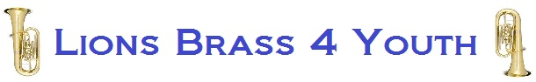

If you are interested in joining, or just trying us out, or would like more information please fill in the relevant sections of this form and return to Lions Brass 4 Youth.
To be filled in by Parent / Guardian.
Name of Parent or Guardian………………………………………………………………Phone…..................................
Name of child………………………………………………………………………………….. Age………
School child attends………………………………………………………………………………………
Email……………………………………………………………….. Phone…………………………………….……………
Delete as appropriate…
Instrument: (Cornet / Trumpet / Flugel / Tenor Horn / Baritone / Euphonium / Trombone / Bass
/ Tuba / Other / do not play one yet)
If other, please indicate…………………………………………………………………………………………………………

Any other information you require from Lions Brass 4 Youth………………………………………………………
…………………………………………………………………………………………………………………………………………………….
Please Note: Membership currently costs £7 per month.
Please attach this form to the email that will be generated when you click here or use the website generated link.

After reviewing your information we will contact you to invite you to an information sharing event.

